Given an m x n binary matrix mat, return *the distance of the nearest* 0 *for each cell*.

The distance between two adjacent cells is 1.

**Example 1:**

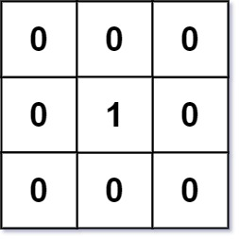

Input: mat = [[0,0,0],[0,1,0],[0,0,0]]  
Output: [[0,0,0],[0,1,0],[0,0,0]]

**Example 2:**

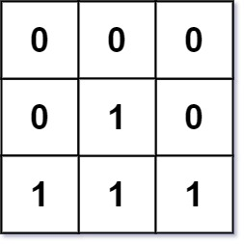

Input: mat = [[0,0,0],[0,1,0],[1,1,1]]  
Output: [[0,0,0],[0,1,0],[1,2,1]]

**Constraints:**

* m == mat.length
* n == mat[i].length
* 1 <= m, n <= 104
* 1 <= m * n <= 104
* mat[i][j] is either 0 or 1.
* There is at least one 0 in mat.